Nepal College of Information Technology
Unit Test
Fall 2011
Program : BE ELX/CE/IT Time : 2 hrs
Semester : Fall (I) FM : 70
Subject : Basic Electrical Engineering PM : 35

- Candidates are requested to give their answer as far as practicable in their own words.
- The figure in the margin indicates the full marks
- Attempt ALL question
1. a) Calculate the power consumed by 5Ω resistor using Nodal Analysis. 7
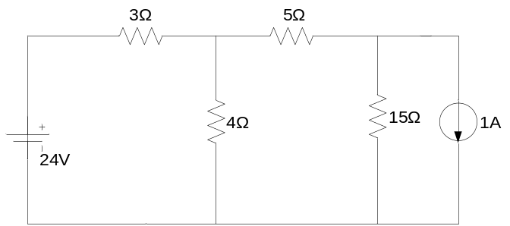
b) Apply superposition theorem to determine the current flowing through resistor of 4Ω in the circuit shown below. 8
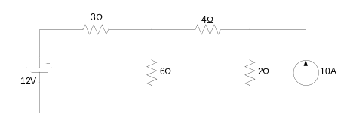

2. a) State Thevenin’s theorem. Find current in 50Ω resistor using this theorem. 8
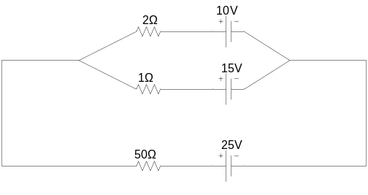
b) State and prove the maximum power transfer theorem and also show that maximum power transferred to the load is P_{Lmax}. = E²/4R_{L} ; where symbols have their usual meanings. 7

3. a) How is single phase alternating emf generated ? Explain with mathematical derivation. 8
b) Define Root Mean Square Value of ac voltage. Show that RMS value is 70.7% of its maximum value. 7

4. a) Find the average and RMS value of the waveform given below. 8
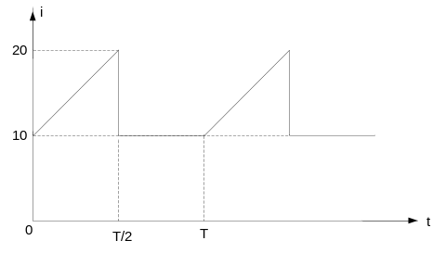
b) Derive the expression of ac current when a pure inductance alone is supplied by an alternating voltage of e= E_{m} Sinwt. Draw proper waveform and phasor showing the phase angle between voltage and current. 7

5. Write short notes on any two of the following: 2*5=10
a) Faraday’s laws of electromagnetic induction
b) Star to delta conversion
c) Emf and potential difference

